**Process Report**

**Project Management System**

Lia Cicati, 304134

Rickie Nielsen, 293624

Loredana Cicati, 304135

Siyu Xia, 305554

**Supervisors:**

Mona Wendel Anderson

Steffen Vissing Andersen

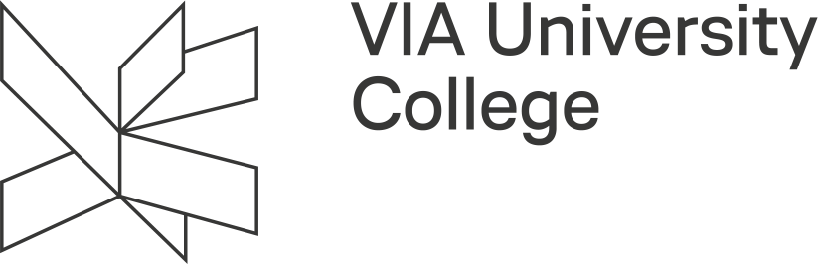

**Software Technology Engineering**

**Semester I**

**18/12/2020**

**Table of content**

1 Introduction 1

2 Group Description 3

3 Project Initiation 7

4 Project Description 8

5 Project Execution 9

6 Personal Reflections 11

7 Supervision 15

8 Conclusions 16

9 Sources of Information 17

10 Appendices 1

# Introduction

As temporary groups are a common practice in the real world, VIA University College provided us with the opportunity to build up relevant collaborative skills.

At the beginning of the semester, temporary groups were formed by the supervisors in order to allow us to get to know our classmates better and see if we all share the same goals and ambitions so we can choose a group where we will be comfortable to hone our skills and contribute as much as we can.

This approach of forming relationships did not work for some of us due to lack of communication skills and a shy nature resulting in staying in the same group circle. For this reason, we decided to form our group based on cultural diversity and prior works during temporary groups.

A few weeks later as our wishes were accepted, the final group was formed.

After that we proceeded to identify the goal of the first-semester project which is to develop a project management system for a company called Colour IT. The main focus is to create a single-user software system to handle tasks and time in order to increase the company’s productivity by minimizing the time spent on gathering project data and reports.

As a result, we will be using knowledge gained from the courses that we had in our first year which are Study Skills for Engineering Students (SSE), Software Development with UML and Java (SDJ) and Responsive Web Design (RWD).

In order to accomplish our goal, the group agreed for the last 2 weeks of the semester to be available all weekdays, meet as often as possible to get the necessary work done.

Below we will include a table with details relating to the work we had done during our process of working on this project.

During each period we reserved several hours to work on. Due to ongoing classes or other several assignments we could not spend the full day to bring the expected output and for that reason we completed them during free hours in the week or weekend.

During week 50 and 51 we spent every day to work on the semester project.

|  |  |  |
| --- | --- | --- |
| **Date or Week Initiation** | **Subject** | **Execution** |
| Week 43 | Analysis start | Requirements and use cases |
| Week 44-45 | Revised version of Requirements and Use cases | Improved work on requirements and use case descriptions |
| Week 45 | Analysis part 2 | 1) Activity diagrams and  2) Domain model. |
| Week 45 | Colour IT Website | Focus: HTML & CSS |
| Week 46 | Revised version of Activity Diagrams and Domain Model | Improved work on Activity Diagram.  Minor changes in Domain Model |
| Week 47 | Design Start | 1) Class diagram and  2) sequence diagrams. |
| Week 47 | Colour IT Website | Focus: Bootstrap and responsiveness |
| Week 48 | The Secret Garden Assignment | Added functionality to the garden |
| Week 49 | Implementation Start | Minor changes to Design so we can proceed with implementation, Added general classes |
| Week 50 | Implementation | Updated general classes,  Made FXML files, ViewModel classes, controllers, Model and ModelManager class. |
| Week 50 | Process/Project report writing | Completed several chapters in the reports |
| Week 51 | Implementation, Testing  Reports, User Guide | Tested methods, added more functionality to the GUI. Completed reports and made a User Guide. |

# Group Description

Our group consists of four members coming from three different backgrounds and cultures such as Denmark, China and Moldova.

As we came to know each other we all realized that we had no project experience prior to the project start.

Before starting VIA’s software engineering program we mostly had tasks that required individual work where we tackled complex problems on our own.

Moreover, no member had enough or even some experience in coding and development which at times made it difficult to provide the final product.

Having worked in a group environment now we understand that it helped to create a deeper understanding of the learning process and it was motivating to acquire skills as relevant as possible to the real world.

**E-stimate profiles**

Rickie Loredana

Siyu Lia

The individual E-stimate profiles we received during our SSE courses helped to understand the behaviour of each team member and allowed us to know some of our personal strengths and shortcomings.

We used these profiles to relate to one another, bring stability and improve our teamwork along the way.

As can be seen, our group consists of two people who have the significant colour blue, followed by green and two people who have green colour as a significant part and right after that blue. The fact that the majority identifies most as blue and green made us to work together towards meeting our common goal and stay determined for the whole time.

The blue part helped us reflect on our group decisions and analyze each step along the process, so we could be specific with our approach. For all of us was important to give quality output by logically putting together an answer that is suitable. Also, it means that the majority of us have a sense of responsibility when it comes to completing tasks and assignments. The green part helped us work in harmony and be considerate towards each other.

However, despite having similar profiles we each took a different role in our group and acted not solely based on these profiles.

Both Lia and Loredana having a higher red preference than the other members turned out to be the initiators of the group. Taking upon this role turned out to be a challenging experience as it came with a lot of stress and responsibilities. Not everyone is born with the talent to lead others but as time went by, we learned how to turn our weaknesses into our strengths, and this led to us focusing more on helping and motivating the other groupmates.

Also, Lia despite having yellow as the fourth preference it was more relevant and characteristic for her personality as she was in charge of providing innovative templates for our system as well as for the website. This behavioural trait showed her creative side.

On the other hand, besides such a difficult role, due to our primary preference that is blue we had roles that defined our personalities more.

Loredana being in charge of documentation provided reliable sources, made sure that project requirements were fulfilled and established traceability concerning what has been done, who has done it, and when it has been done.

Lia being responsible for the quality of the work was able to recognize mistakes and details that otherwise would have been overlooked and gave precise feedback along the process.

Siyu is responsible for the simplest and most basic part of the project so that further work can be started，and do some work assigned by the leader.

The main responsibility for Rickie has been to support the group and provide feedback on our different assignments and project related work in a constructive manner, this has helped the group in getting a better understanding of the problems we have run in to and often led to us finding a simpler solution than what we had first anticipated.

**Cultural background**

Apart from personality profiles cultural background played a major role in our group work. Despite our differences we managed to come together and give our best to the group so everyone can be satisfied.

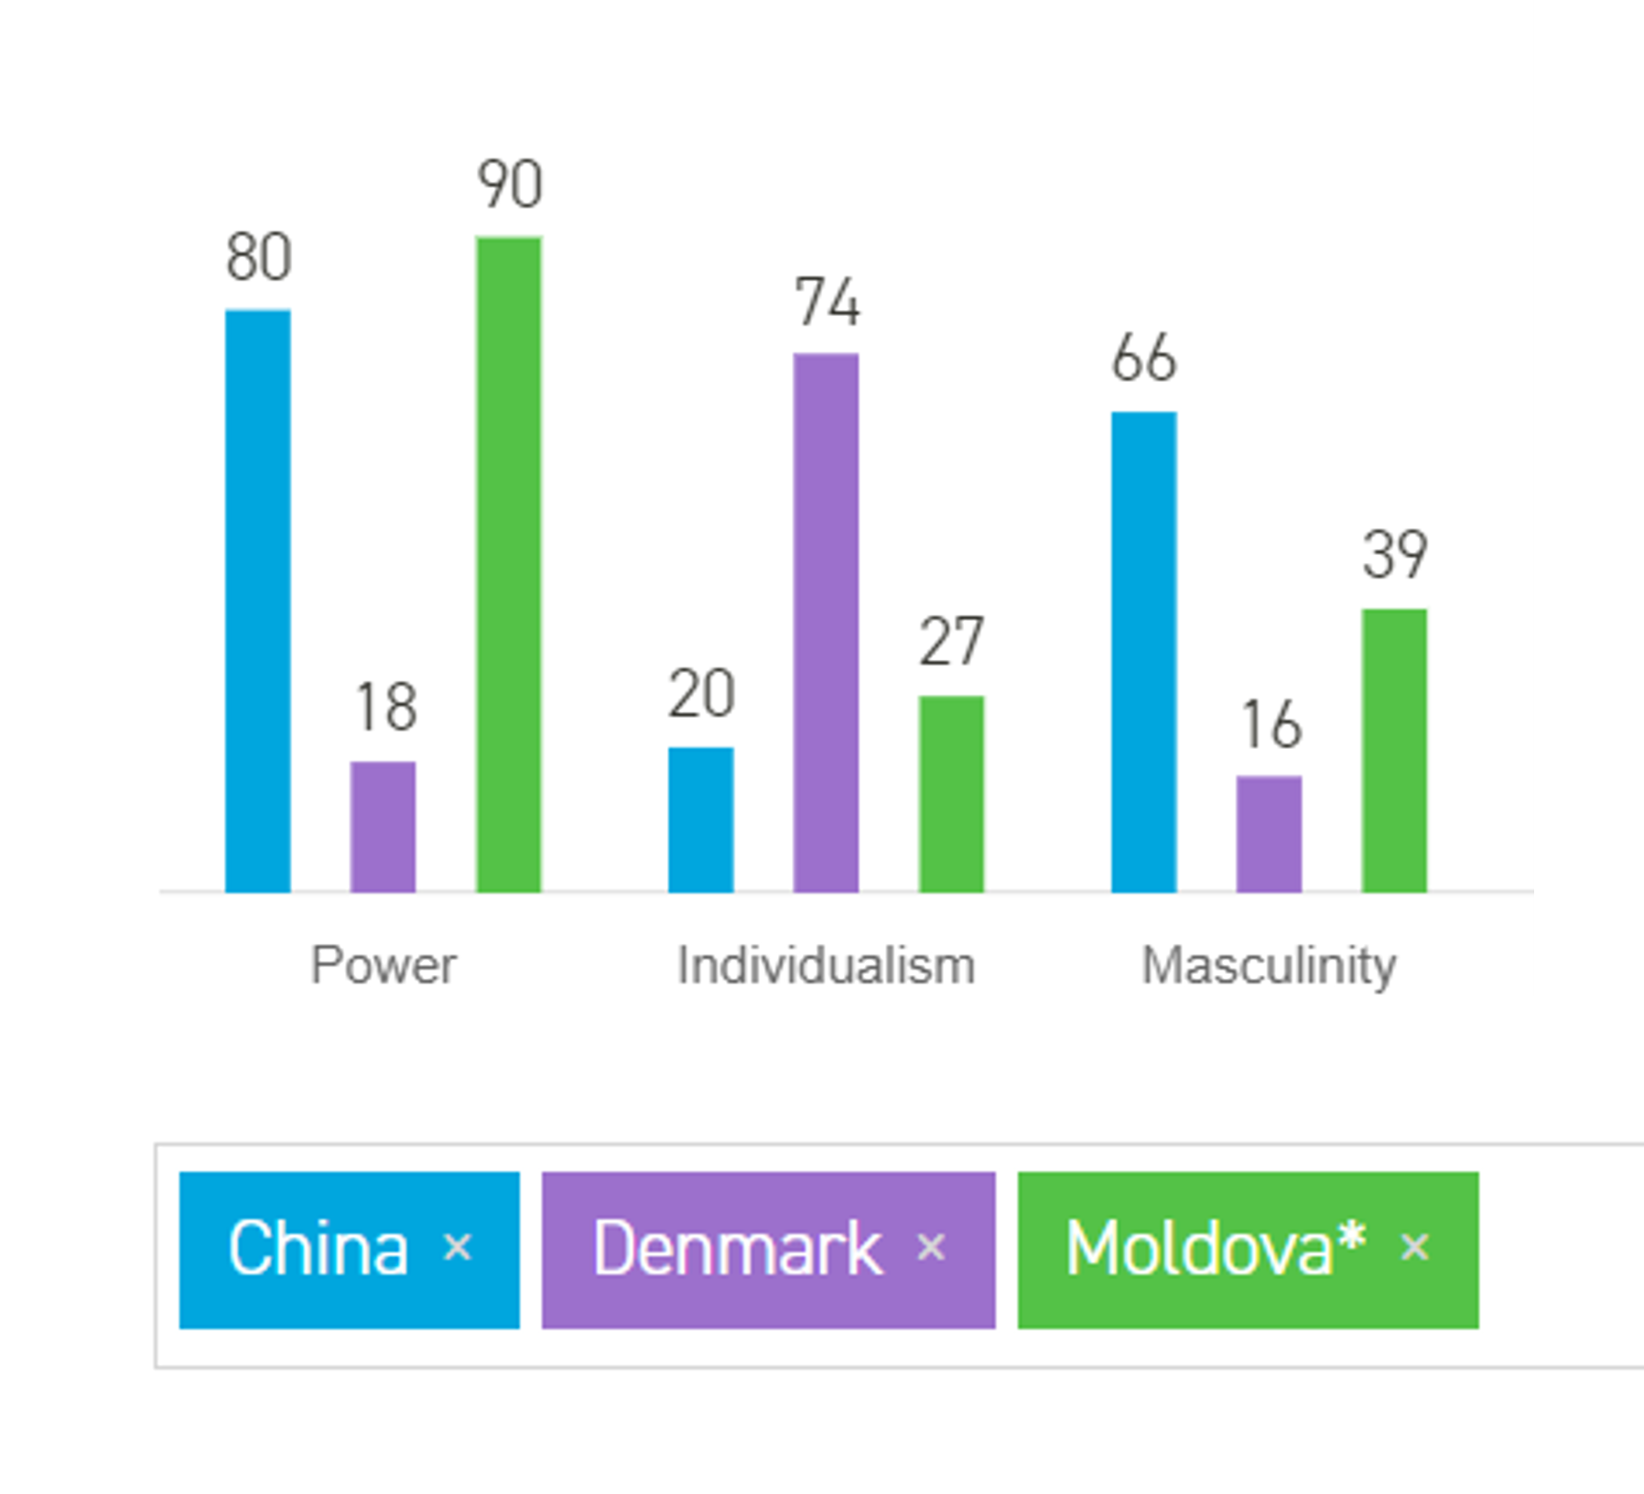

**Siyu Xia: China**

**Rickie Nielsen: Denmark**

**Loredana Cicati: Moldova**

**Lia Cicati: Moldova**

As in can be seen in diagram above, we can describe the cultural background of our group, depending on some of the dimensions of culture that Geert Hofstede analyzed.

Generally, our group with two people from Moldova and one from China based on the diagram is said to have high-power distance where everyone accepts someone to be in charge and to take decisions with no further justification solely based on their status (Hofstede Insights).

However, we relate more to the low power distance that Denmark has because we prefer an independent environment where everyone can contribute equally. Moreover, there is no arrogance in our communication, and we tend to decide something by making a compromise and accepting each input. This shows that not everyone in a society is programmed in the same way. There are significant differences between individuals.

The majority of us are also supposed to be very collectivistic based on the diagram. We find this to be somehow accurate because it is true that some of us do have these traits such as thinking of the harmony

of the group and trying our best to ensure the success of the team. However, as three members Lia, Rickie and Loredana self-identify as more individualistic and Siyu as collectivistic for the most part we focused more on the task rather than forming relationships with one another. As an example, could be that small talk was kept at a minimum. We realized that for us communication should be precise and detailed.

Lastly, as shown in the diagram Rickie, Lia and Loredana come from a feminine society. We find this to be very accurate because we care about the quality in our working lives rather than focusing merely on competition and ensuring success. We think that gaining knowledge and receiving quality output are the main criteria to achieve success later on and not just exam scores.

On the other hand, Siyu comes from a masculine society. He admits that he studies hard so that he can get a higher salary in the future. From his perspective if you do not work hard, you will be defeated by others. That is why he as a team member wants the team's performance to stand out by getting a higher score in the exam.

# Project Initiation

Before the case presentation, during week 37 based on our personal choices the final group was formed.

After several days we made our group contract where we decided on different rules that will help improve our development. (see Appendix A)

During week 38 we were assigned partner groups. This was done so we can give and receive constructive feedback related to the semester project assignments.

The same week we were presented a case precisely a customer interview where the subject was a company called Colour IT.

We were tasked to describe the company and what it is that they would like to be able to do.

Firstly, we took notes using one of the note-taking techniques we learned in one of SSE lectures.

The Cornell Method helped us summarize all the information about the company and their requests in a systematic manner. (see Appendix B)

The base of this case was that Colour IT which is developing and implementing IT systems mostly for private customers has no project management system to handle tasks and time for their IT projects. In the interview they started to describe their current work procedure and moved on to explaining what they would like to be implemented in a system so they can easily provide effective completion of projects.

After that we were asked to write down relevant questions related to the case which were answered afterwards at the customer meeting that took place on September 16, 2020.

Even tough at the start we were overwhelmed by the amount of information we received while reading the interview by ourselves, after the meeting we began to have a clearer idea of what is it that we are supposed to do and how to approach this case in particular.

Having answers to our specific questions we proceeded to analyze the customer’s wishes more thoroughly which helped us understand better the general scope of the project.

The initiation part of the project turned out to be a very important step as it helped us improve our skills regarding documentation and overall made us understand more the problem we were faced with.

During this period, it became clear that each project requires students' research work. A distinctive part regarding all of this was the constant search for information, which then was processed and comprehended by the members. We managed to learn something new every day and use this gained knowledge in the execution part of the project. Once we had this foundation, we were to some extent ready to step further in the process.

# Project Description

The first task we did after the formation of final groups was writing a Project Description which we used all through the project work.

It all started with coming up with ideas and figuring out how to split the work so we can give quality output in a timely manner.

When writing the project description, we realized that this was an opportunity to enter the customer’s world and get to the bottom of what exactly is a project management system and its prime function.

During our research we concluded that it can be considered a tool that helps to accomplish various tasks as well as provide success and growth by increasing the company’s efficiency and productivity.

After finishing writing the first draft containing 8 written chapters, we were told to make a video presentation covering only the main information from the project description. Apart from that we had to send the first full version of our description to our supervisors and partner group that was assigned during the project initiation phase.

Once we submitted it, we were reviewed both by our supervisors and partner group.

It was a very helpful experience on both parts because as we learned during one of our sessions in SSE peer review requires a deep understanding of the task. This means that we had a chance not only to receive feedback but asses it also to our partner group. We acquired more knowledge during this time because reviewing someone’s work meant going back to the roots of the given case and slowly seeing if all requirements set by our supervisors were met. Analyzing the case in more depth also meant finding better ways to improve our work. We learned what are the good parts that we as well can use in our group as well as things that would be better to avoid.

Overall, the feedback we received was very insightful as they analyzed our work from another perspective and pointed out some things that we might have missed.

Due to constant feedback, we become more confident regarding our skills and that helped us come closer to the goal we set which was to develop a simple yet effective system. This turned out to be a realistic goal which required dedication and hard work from all the group members.

As mentioned in the beginning the project description was used during the whole process of working on our semester project. We often looked at the problem statement as well as purpose to continually remind ourselves about the aim of the project.

Apart from that we also reflected on the risks we set from the start which helped avoiding them or taking the right actions when things went wrong.

Looking back, it was a constant motivation to all of us as it served as the base for our following works.

# Project Execution

**Methods**

For our first semester project we were supposed to follow the waterfall approach by splitting the project into phases such as Analysis, Design, Implementation and Testing.

By using this method, we focused on doing tasks in a succeeding order without changing the completed tasks. However, this turned out to work for the earlier phases but as we progressed, we realized that we could not go further without making some changes everywhere.

We found this to very constraining and in order to achieve a proper functional system we ended up not following this approach entirely.

As a different solution, we used the iterative approach which provided more freedom and flexibility. Instead of stressing over how to deliver a project as a whole it was much easier to go back to each phase and make the changes accordingly.

After having worked on the project, we decided that it is better to not use the waterfall method as many issues occurred while using this specific approach. If starting it over again we will definitely lean more towards the iterative approach as it ensured more quality for the overall goal that we had in mind.

Along with using these methodologies, to make the work process easier we decided on several online tools.

First of all, we used **Figma** - an interface design application to provide templates for both the system and website wanted by our customer company Colour IT. (What Is Figma? ,2018)

When starting to implement the methods from our Design phase we decided to use **GitHub** which is a code hosting platform for version control and collaboration which let us work together on projects from anywhere.

(GitHub Guides, 2020)

Together with GitHub we used **GitKraken**. It turned out to be of great use as it allowed us to keep up to date with the changes without being burdened to send the files over and over again to each other as we had the same files on every computer.

For communication we used the platform **Facebook** where we planned our meetings and sent some relevant information to the project itself such as updated class diagrams and so on.

Whenever we decided to work from home, we used **Discord** to communicate in our voice channel. There we often used the feature of sharing the screen for going over some tasks and explaining our approach to different methods.

**Project results**

After applying all these methods, we were able to have an overview of our work that has been done so far.

Firstly, during the Analysis and Design phase we managed to handle everything on time and received good feedback that allowed us to improve our project. We were satisfied with the results we got during these phases, since we dedicated a lot of time to it and it proved to be worthwhile. We had in mind from the beginning to take Design as serious as possible because we were often told that if we have a good design then it will make coding less challenging. By following this advice, we did not spend extra time on changing everything when moving to the Implementation phase. Changes only occurred during implementation when some methods proved to be unnecessary or we needed to add more to make the system functionable.

Moving on to the Implementation Phase we were met with a lot of problems.

The results were not satisfactory as some of the requirements were not fulfilled due to time constraint. We spent several days researching different methods and ways to approach a specific task which made the development process to be held back.

Two weeks seemed too short in order to complete the needed work and it made the experience stressful.

Overall, for everyone it was a learning experience that made us rethink our priorities, work harder to achieve the wanted results and seek for guidance when things seem hard.

**Tasks completion**

In this part we will include what each member has mostly worked on during the semester project as well as tasks everyone tried to be involved in.

***Every member participated on:*** Requirements, Use Cases, Activity Diagrams, Design for separate class diagrams, Implementation for General and List Classes, Java Documentation, Website Focus: HTML & CSS, Focus: Bootstrap and responsiveness

***Lia Cicati:***

Project Description, Relation between requirements and use cases, GUI, Implementation, Exceptions, Testing, User Guide, report chapters, Blueprint for GUI and website design.

***Rickie Nielsen:***

Domain Model, Sequence Diagram, Persistence, Implementation, Exceptions

***Loredana Cicati:***

Project Description, Relation between requirements and use cases, Updated Use case descriptions and activity diagrams, Domain Model, Full Class Diagram, Implementation for ViewModel Class, report chapters

***Siyu Xia:***

GUI, Implementation for ViewModel Classes

# Personal Reflections

**Loredana Cicati**

The reason I aspired to study in Denmark was to acquire new skills by studying approximately real-life work situations. This in my opinion could be done by project organized studies. Later on, this was proven by working on the semester project which helped me put in practice the theoretical knowledge learned to practical problems. Along the way I found many advantages for both group work and problem-based learning.

Problem-based learning gave me the possibility to have a much deeper subject understanding. It contributed to the cooperative learning and development of different communicational and analytical skills which I applied in the group environment where I was exposed to the challenges of different work processes. This gave me an insight in how to listen and accept diverse work styles and sometimes improve myself as well.

For group work an important part was gaining more confidence in expressing my opinions and presenting new ideas to the group. Also, through discussion and explanation I learned a lot more things from others than I could have learned by myself.

However, there were some difficulties during the entire process.

If trying to think of disadvantages one thing that comes to mind is the thought of relying on other people.

From experience, I always could only count on myself. However, group work means putting your trust in the people around you. I wanted to not be so hard on myself and give other people the chance to prove themselves.

Unfortunately, despite being always available and completing the assigned tasks there were instances when the input was not delivered to a maximum and the outcome was not satisfactory resulting in redoing the work all over again.

This led to the feeling that if someone did not step in, we would not make any progress. As a result, I personally felt emotionally exhausted and drained, especially during the last week of developing the system and making the needed documentation.

Another disadvantage were the time restrictions. My initial thought was that by splitting the tasks we will not be pressured by time and instead could focus more on delivering the final result. However, the lack of skills during the implementation phase from all members of our group made the experience stressful and at times impossible to handle.

One of the many things that I would try differently next time I will be involved in group work is to encourage change and not just settle on something that is comfortable but rather come up with different approaches to

get everyone motivated so they can participate equally in the workload. This all comes down to communication strategies. If not handled properly some issues may arise.

As for me, I felt that because of the inability to address some problems or denying that the problems exist to begin with better understanding and cooperation were at risk. Friedrich Glasl’s Conflict Escalation Theory emphasizes how in the win-win facilitation stage specifically in the tension part the conflict is not voiced at this stage as it is often not recognized as conflict yet. (Friedrich Glasl's book “Konfliktmanagement. Ein Handbuch für Führungskräfte, Beraterinnen und Berater”). In my opinion this shows how there is an internal logic to conflict relationships and the reason why I never went further than this stage.

Having analysed this I now know that I should initialize straight and fair conversations. Also, it is important to be more engaging by asking more relevant questions and having more confidence in myself so other team members feel comfortable keeping the conversation going.

**Siyu Xia**

The reason why I came to Study in Denmark is because I heard that there is a top-notch software engineering major here, which is different from the teaching method in China. In Denmark, we can test the skills we have learned by doing a project instead of just taking an exam.

In the first semester, we received the first project, where strangers from different countries got together and tried to solve problems.

Fortunately, my team members were very tolerant to me. Everyone communicated with me very patiently, fully respected my opinions, made me feel very involved, and taught me many tools to use in programming, for which I was especially grateful.

Indeed, doing this project, from summarizing interviews to building models to actual programming, is really a big project, which makes me feel the pressure of real work. I think I may try to share my ideas more in the future, rather than just listening, and it would be better to improve my communication skills while practicing my professional skills.

To be honest, I did not do much in this project, and the results were always full of loopholes. However, I will work harder in the future to master skills, so that I can do more in the project and share the pressure of others.

In the short three months since I came to Denmark, I did not have much time to get to know each other well. I hope we can have a chance in the future.

**Rickie Nielsen**

The main reason I decided to come to VIA to study Software Engineering is because I have spent the last 11 years working my way up the “corporate ladder” within the company I used to work for, before I finally came to the realization that it was simply not an industry I wanted to work in, and the job did not give me any real sense of achievement. When I finally realized this, I started thinking more into the future and about what my goals and ambitions are.

My time spent on 1st semester here at VIA has been a major change in how I need to approach and overcome challenges, since before coming here, all the work I have been doing has always been in a solo scenario, meaning I have always had to figure out the solutions on my own without a team to talk things over. This is not a valid approach anymore, since we got assigned to a group early in the semester that we now must work with on our major projects and assignments. This was hard to get accustomed to at first since this is not how I am used to working but looking back I find that this has been a very beneficial way to work because now I can get input and feedback that enables me to look at the problems at hand with an entirely different perspective.

Overall, I feel this 1st semester has laid a good foundation for what is to come and helped me realize what I need to improve on to expand on my own personal skills and the skills needed to help my group achieve the desired results that each of them have.

**Lia Cicati**

When I think what exactly motivates me, I always conclude that one of the biggest motivators tends to be the skills I can gain every time I involve myself in some new activity. Sometimes for this to happen I must leave my comfort zone, but the new knowledge and competences obtained afterwards are always worth it.

That is why not long before starting my studies at VIA, I registered to a practice-oriented bootcamp, to the Web Development program, my desire being to obtain a sense of what it is like to work on real life projects, keeping up with deadlines and acquire useful skills that I will be able to put into practice whenever I will find the right place to do so.

Software Technology Engineering program at VIA felt to be the right choice for me as it embraces Problem Based Learning as its main approach of learning meaning that the new knowledge acquired here can fulfil my needs to better identify the source of the problems in specific social environments and understand afterwards conditions that are needed to design and solve solutions.

The actual time spent here on first semester made me more flexible, more detailed oriented as the result relied on decisions we made during different phases of our work. For this reason, I tried to give my all and approach everything very careful. Besides of gaining new skills I had the opportunity to share some useful techniques with my group mates, making the first period of our work easier.

The hardest part of the actual process of delivering a good result was the fact that not all members of the group had the same approach when it came to analyse problems and give different solutions. Even tough in the Group Contract we all agreed to brainstorm and suggest different ideas and solutions, I felt sometimes like almost everything relied on my shoulders, meaning that unfortunately not all of us delivered to a maximum. According to Self Determination Theory by Deci and Ryan, “Autonomous individuals can choose to work alone or can rely on others yet still gain a sense of intrinsic motivation from engaging in tasks.” Not being able to always rely on others, I spent a lot of time trying to understand the actual problem we were given and taking important decisions so that we were able to proceed to the next stages of the work.

At first this was not that much of a problem as I was thinking that maybe my expectations are too high, and I tried to convince myself that things cannot be controlled and managed as we expect them because of our different perceptions towards different situations but when we proceeded to the actual implementation, I started to feel a lot more pressure and stress, being unable to rely on all my teammates. It felt like we were not making enough progress and the amount of work that had to be done in a constraint period of time made this experience even harder.

Despite how challenging this whole experience was, I learned a lot about group work, managing my time correspondingly and most significantly how to apply theoretical knowledge in a more practical environment.

# Supervision

In order to proceed with completing some tasks we needed some guidance from our supervisors.

Most communication was held online on Discord due to the current situation.

The first supervisor meeting took place Wednesday on the 2nd of December 2020 with Steffen Vissing Andersen.

The agenda for the meeting was Design Overview and some additional questions.

We were satisfied with the cooperation with our supervisor as he pointed out some important part in our design which made it easier to start working on the Implementation phase. After the consultation we became more confident in our work and proceeded with more complex tasks.

The second supervision meeting was held Tuesday on the 15th of December 2020.

As we ran into different problems during the implementation of our system, we needed some help to realize what was going wrong and what can we do to avoid further issues. The discussion provided some clarity on some parts of the code. However, despite our efforts some suggestions offered could not be implemented in our system.

For instance, we had a problem in the GUI part and the solution provided was not effective enough as the system was too complex and further modifications were required which were impossible to redo due to the time limit.

The final meeting was on the 17th of December 2020. As it was the last meeting before the deadline our agenda was going over the criteria for upload. After the discussion we managed to organize the project so it can be ready for the hand-in.

Apart from that, we contacted our supervisor also via email to get some clarifications on certain topics.

The supervisor took the time to provide clear answers and was of great help in explaining the first steps in how to approach a complex task.

# Conclusions

After working in a group, we all came to certain conclusions and learned many lessons which we will apply for our future works.

Firstly, it is very important to have a group with similar determination and work ethic.

For some a sense of responsibility and diligence is not an inherent ability, however if you show steady effort

and work on your motivation it is possible to bring quality output.

This can be done by taking the time to understand the tasks and not rush to complete assignments or wait until the last minute because the quality work could be lower.

Secondly, when members do not share the same goal or motivation, it is very hard to achieve a good result. Scores and grades are a reward, but they do not define everything. What is most important is to acquire knowledge so it can be applied during later studies. As long as you know what you are doing and can explain it then you can aspire for a higher grade and performance at an exam.

Discipline and hard work should be the values that define a functional group.

Another thing is that being present means more than attending meetings. It involves being active, taking part in discussions, asking questions and giving ideas.

To contribute satisfactory, we have to make sure that it is relevant to the subject and can be applied to solve arising problems rather than holding back the process by fixing new errors.

This leads to next thing which is giving feedback to each other on assigned tasks. By doing this we were able to understand the approach that has been chosen by every member and see the work from a different perspective.

When giving feedback we made sure to have regular meetings to discuss the process so everyone can stay on track with the work.

Finally, we learned that time management is the key to being as productive and successful as possible. Due to some delays regarding some problems with the system everyone started to feel anxious and pressured when approaching the deadline which made it difficult to focus and deliver everything to a maximum.

Here is our list of recommendations for future group work:

1. Be active

2. Have clear goals and visions on how to approach a certain task.

3. Do not rush when completing assignments

4. Give precise feedback for the completed tasks

5. Show effort and determination

# Sources of Information

Hofstede Insights. (2020) *Country Comparison* [online] Available at:

<https://www.hofstede-insights.com/country-comparison/> [Accessed December 7, 2020]

What Is Figma? (2018) *Web Design Figma* [online] Available at:

<https://webdesign.tutsplus.com/articles/what-is-figma--cms-32272> [Accessed December 8, 2020]

GitHub Guides. (2020) *What is GitHub?* [online] Available at: <https://guides.github.com/activities/hello-world/> [Accessed December 8, 2020]

*GANTTPRO, (2016) Agile vs Waterfall: Pros and Cons, Differences and Similarities* [online] Available at:<https://blog.ganttpro.com/en/waterfall-vs-agile-with-advantages-and-disadvantages/> [Accessed December 8, 2020]

Basic psychological needs (2019) *Why the basic psychological needs autonomy, competence and relatedness matter in management and beyond* [online] Available at:<https://www.ckju.net/en/dossier/why-basic-psychological-needs-autonomy-competence-and-relatedness-matter-management-and-beyond>? [Accessed December 13, 2020]

Problem-Based Learning (2016)-*An Overview of its Process and Impact on Learning* [online] Available at: [*https://www.sciencedirect.com/science/article/pii/S2452301116300062*](https://www.sciencedirect.com/science/article/pii/S2452301116300062)[Accessed December 15, 2020]

-Friedrich Glasl : *“Konfliktmanagement. Ein Handbuch für Führungskräfte, Beraterinnen und Berater*

# Appendices

[Appendix A: Group Contract](Appendix%20A)

[Appendix B: Group Notes](Appendix%20B)